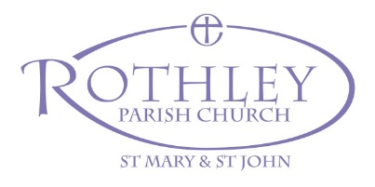

Agenda for the Meeting of Parishioners
To be held in Church on Sunday 7th April 2024 at 11.00am

A joint meeting of:

- the persons whose names are entered on the Church Electoral Roll of the parish and….

- the persons resident in the parish whose names are entered on the Register of Local Government Electors by reason of such residence.’
Churchwardens Measure
1. Opening prayers and reading
2. Minutes of the 2023 Meeting of Parishioners (already circulated)
3. Election of Churchwardens

Agenda for the Annual Parochial Church Meeting
To be held on Sunday 7th April 2024 at 11.15 am

‘All lay persons whose names are entered on the Church Electoral Roll of the parish shall be entitled to attend the annual meeting and to take part on its proceedings, and no other lay person shall be entitled.’
Churchwardens Measure

1. Apologies for absence
2. Minutes of the 2023 Annual Parochial Church Meeting (already circulated)
3. Matters arising from the minutes of the 2023 Annual Parochial Church Meeting
4. Report on changes to the Church Electoral Roll
5. The Annual Report & Accounts for 2023 (already circulated)
6. Treasurer’s remarks
7. Elections to the Parochial Church Council
8. Appointment of Independent Examiner of the accounts for 2024
9. Correspondence
10. Updates:
• Church Building Improvements Project
• Shaped By God Together: Minster Communities
• Evangelism
11. Questions to church officers
12. Closing prayers

